Chris Carrier

9/24/13

#1

<!DOCTYPE html PUBLIC "-//W3C//DTD XHTML 1.0 Strict//EN"

"http://www.w3.org/TR/xhtml1/DTD/xhtml1-strict.dtd">

<html xmlns="http://www.w3.org/1999/xhtml">

<head>

<title>Validate Credit Card</title>

<meta http-equiv="content-type" content="text/html; charset=iso-8859-1" />

</head>

<body>

<h1>Validate Credit Card</h1>

<?php

$CreditCard = array(

"",

"8910-1234-5678-6543",

"0000-9123-4567-0123"

);

foreach($CreditCard as $CardNumber){

if(empty($CardNumber)){

echo"<p>This Credit Card Number is invalid because it contains an empty string.</p>";

}

else{

$CreditCardNumber = $CardNumber;

$CreditCardNumber = str_replace("-", "", $CreditCardNumber);

$CreditCardNumber = str_replace(" ", "", $CreditCardNumber);

if(!is_numeric($CreditCardNumber)){

echo "<p>Credit Card Number " . $CreditCardNumber . " is not a valid Credit Card number because it contains a non-numeric

character. </p>";

}

else{

echo "<p>Credit Card Number " . $CreditCardNumber . " is a valid Credit Card number.</p>";

}

}

}

?>

</body>

</html>

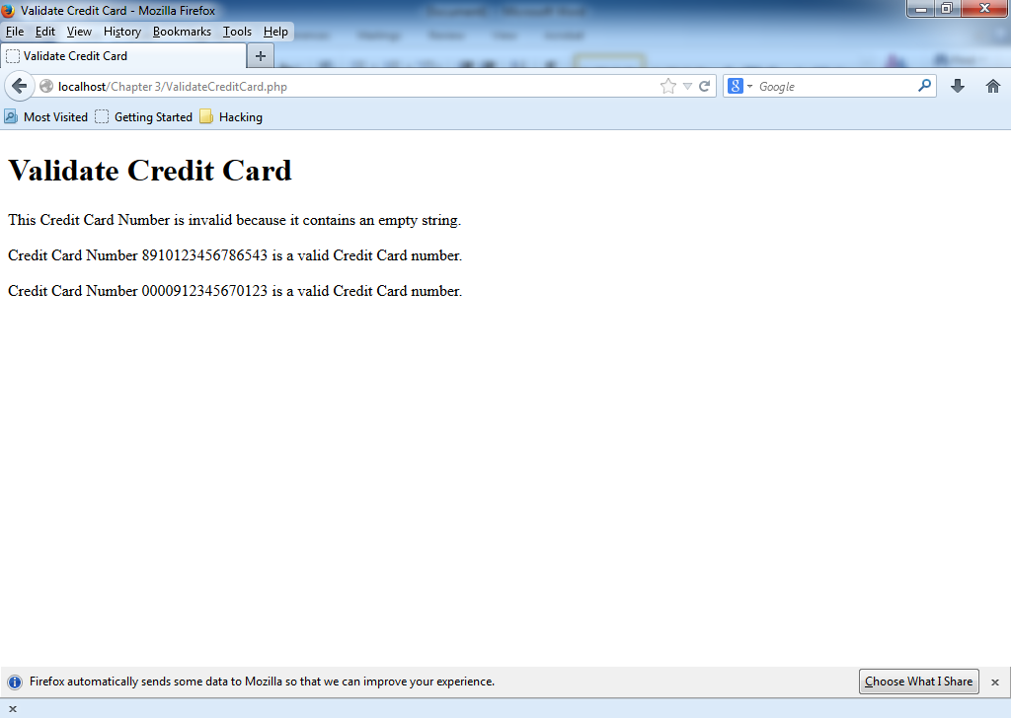

#2

<!DOCTYPE html PUBLIC "-//W3C//DTD XHTML 1.0 Strict//EN"

"http://www.w3.org/TR/xhtml1/DTD/xhtml1-strict.dtd">

<html xmlns="http://www.w3.org/1999/xhtml">

<head>

<title>Validate Local Address</title>

<meta http-equiv="content-type" content="text/html; charset=iso-8859-1" />

</head>

<body>

<h1>Validate Local Address</h1><hr />

<?php

$email = array(

"jsmith123@example.org",

"john.smith.mail@example.org",

"john.smith@example.org",

"john.smith@example",

"jsmith123@mail.example.org");

foreach($email as $emailAddress){

echo "The email address &ldquo;" . $emailAddress . "&rdquo; ";

if(preg_match("/^(([A-Za-z]+\d+)|" . "([A-Za-z]+\.[A-Za-z]+))" .

"@((mail\.)?)example\.org$/i", $emailAddress) == 1){

echo " is a valid email address. <br />";

}

else{

echo " is not a valid e-mail address. <br />";

}

}

?>

</body>

</html>

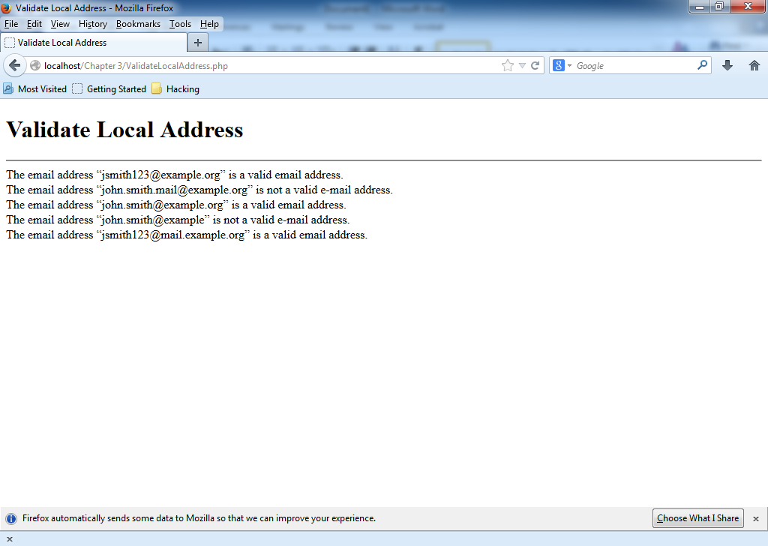

#3

<!DOCTYPE html PUBLIC "-//W3C//DTD XHTML 1.0 Strict//EN"

"http://www.w3.org/TR/xhtml1/DTD/xhtml1-strict.dtd">

<html xmlns="http://www.w3.org/1999/xhtml">

<head>

<title>Password Strength</title>

<meta http-equiv="content-type" content="text/html; charset=iso-8859-1" />

</head>

<body>

<?php

$Passwords = array( //At Least 10 Test's, at least 6 fails, at least 4 passes

// 1 fail all tests, 1 fail length test

"Password#",//No Number

"Password1",//No special character

"Simon#1",//Less than 8 characters

"chris#21",//No Uppercase

"CHRIS#21",//No lowercase

"Chris #21", //Failed because of space

"Christopher#12/19/1991", // +16 characters Too long

" ", //FAILS EVERYTHING WEEEEEEE

"Password#2048", //Pass 1

"Simon68%", // Pass Test 2

"Scream#5", //Pass Test 3

"TammySmith#1", // Pass Test 4

"Mississippi'13", //Pass Test 5

);

foreach($Passwords as $PasswordTest){

echo "The Password &ldquo;" . $PasswordTest . "&rdquo; ";

if(preg_match("/[^0-9A-Za-z]/", $PasswordTest) == 1){

echo " is a Strong Password. <br />";

}

else{

echo " is not a Strong Password. <br />";

}

}

?>

</body>

</html>

